WDAIL Shirt Order Form
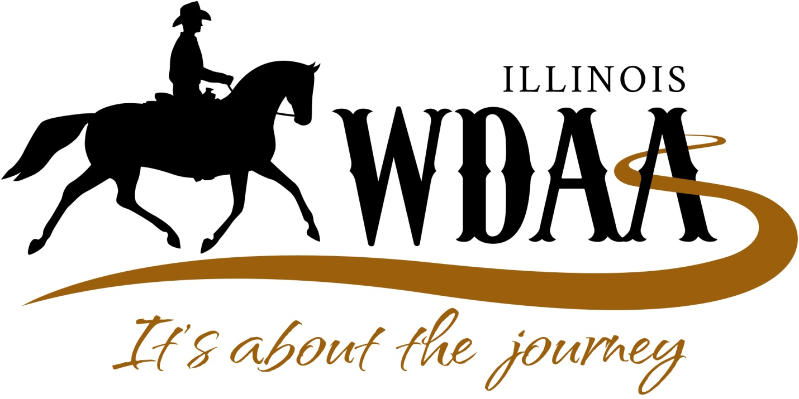
WDAIL is offering shirts for sale so our members can pick them up at the WDAIL table at the Illinois Horse Fair 2016 and wear them at the Horse Fair and everywhere. Shirts will have the logo above on them.
Order Information
Name:
Cell phone number:
Email address:

YOU MUST SEND YOUR ORDER WITH PAYMENT BY FEBRUARY 20TH IN ORDER TO RECEIVE YOUR SHIRTS AT THE HORE FAIR.
Shirt Type | Size | White | Black | Gray | Navy | Quantity | Price Each | Amount
Hoodie | S |  |  |  |  |  | $30
 | M |  |  |  |  |  | $30
 | L |  |  |  |  |  | $30
 | 1X |  |  |  |  |  | $30
 | 2X |  |  |  |  |  | $32
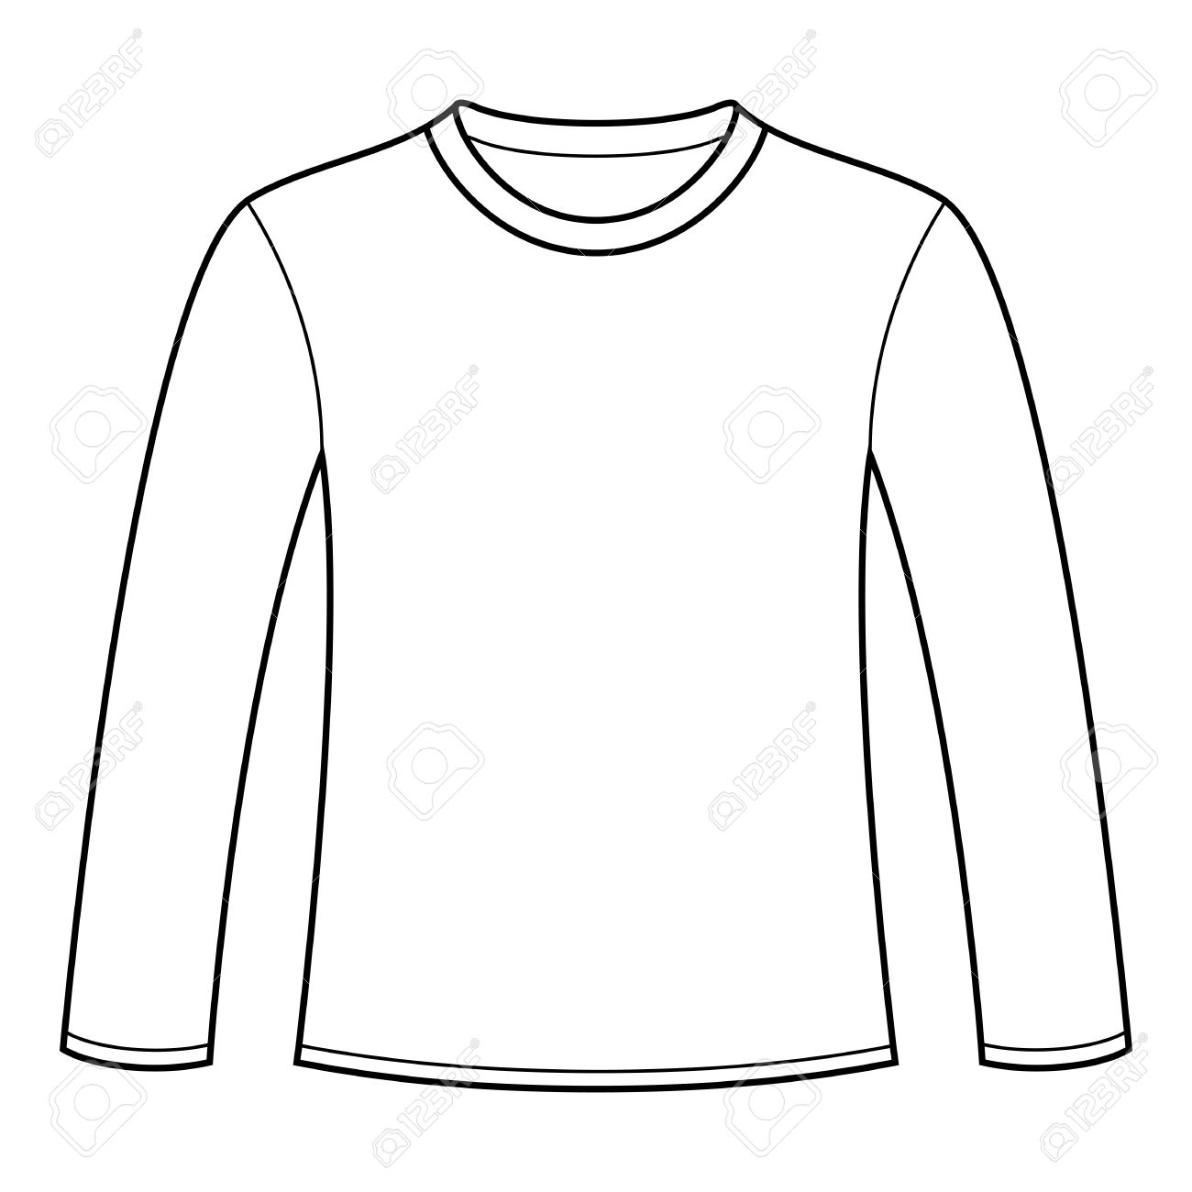Long sleeved  T-shirt | S |  |  |  |  |  | $15
 | M |  |  |  |  |  | $15
 | L |  |  |  |  |  | $15
 | 1X |  |  |  |  |  | $15
 | 2X |  |  |  |  |  | $17
Short sleeved  T-shirt | S |  |  |  |  |  | $12
 | M |  |  |  |  |  | $12
 | L |  |  |  |  |  | $12
 | 1X |  |  |  |  |  | $12
 | 2X |  |  |  |  |  | $14
TOTAL DUE:

Make checks payable to WDAIL and mail completed form with payment to:

Mary Skittino -WDAIL
1801 Lemen Road
O’Fallon, IL 62269

